Dated 27-02-2024

URL : <https://www.youtube.com/watch?v=q8bRZ3rLaJw> ( Shubham )

URL : <https://www.youtube.com/watch?v=CSW3Pc8Kx1E&list=PLlfy9GnSVerQu-uL0AdI3O5VzUmIv5pPf> ( Channel

Basics

**Shell Scripting For DevOps | Free Course Launch on TrainWithShubham**

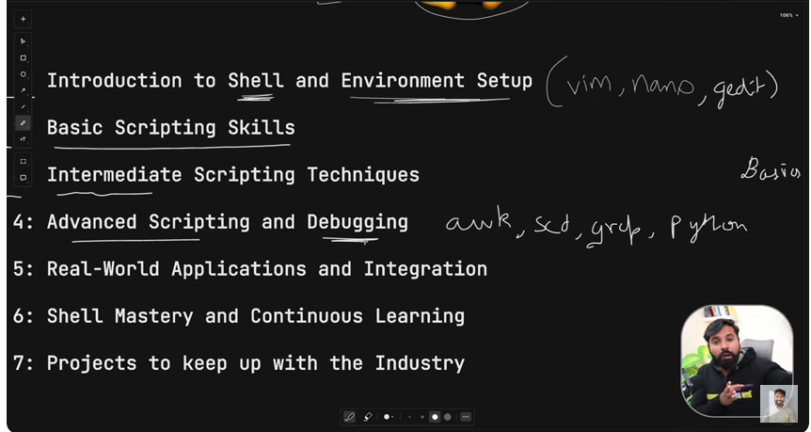

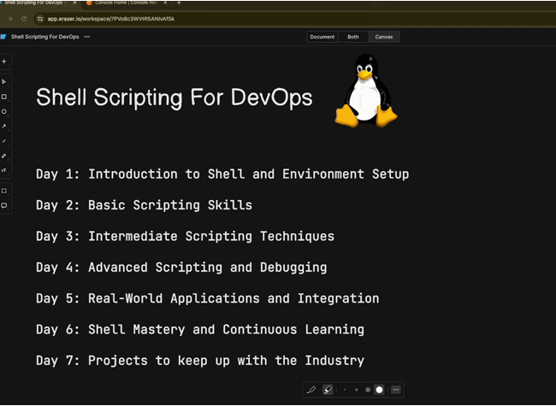

**Learn Shell Scripting for DevOps in just 30 Minutes | FREE COURSE (Day 1)**

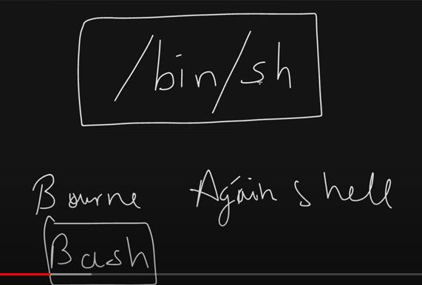

Corn shell

Launch EC2 Instance

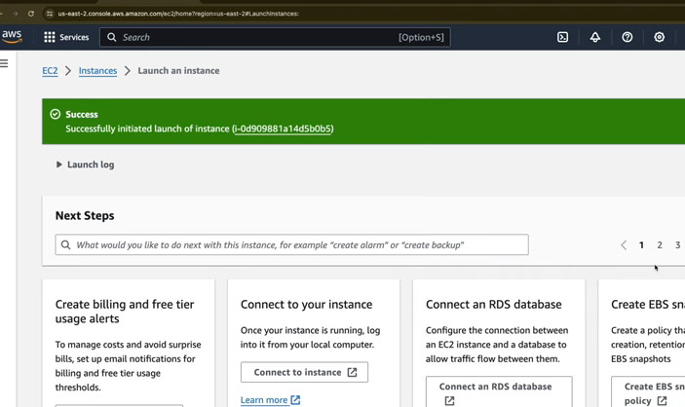

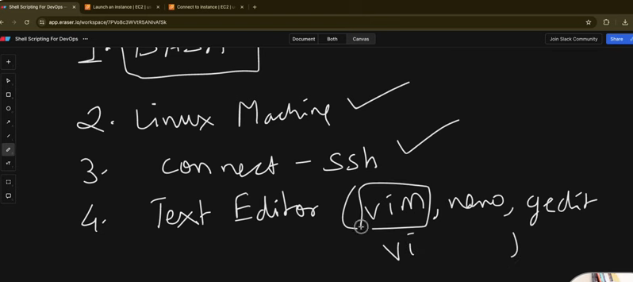

Edit vi hello.sh

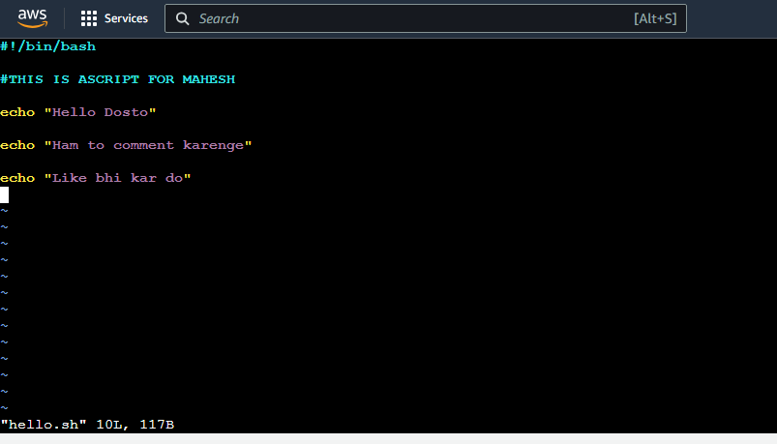

To Save type

:wq

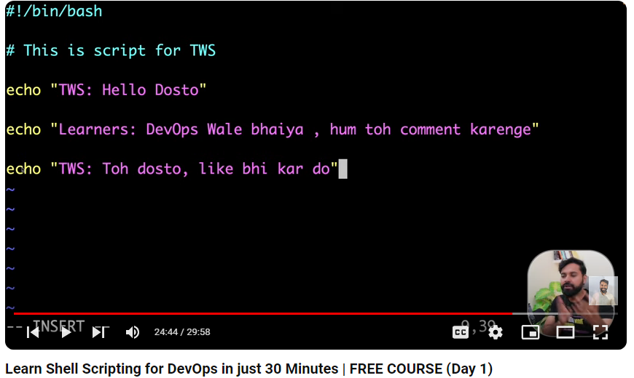

This is ashell scripting commands

How to execute by permission

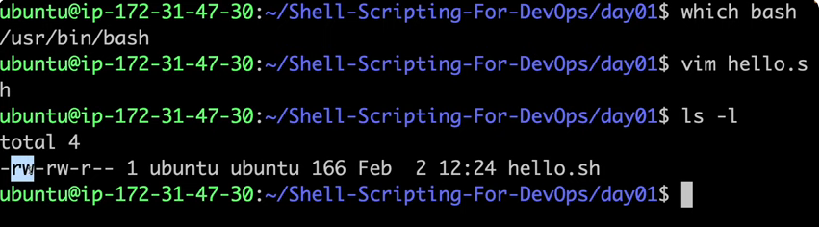

Beow are the file permissions need to gove chmod 754 hello.sh

To run a shell sript

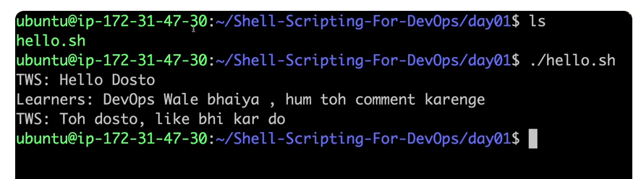

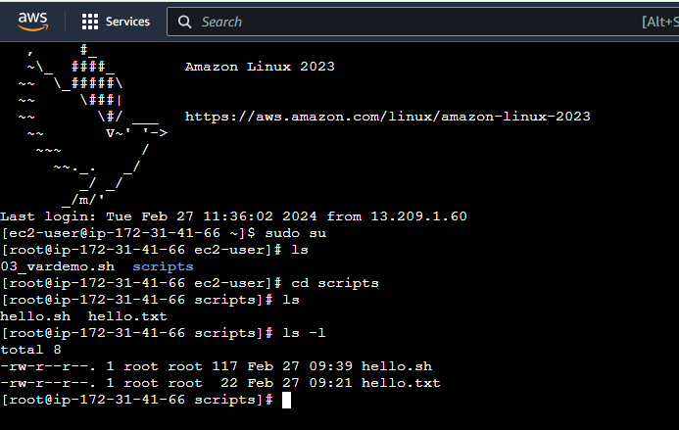

Permission need to change

Chmod

Green stand for executable file

**Master Basics of Shell Scripting for DevOps in 1 Hour | FREE COURSE (Day 2)**

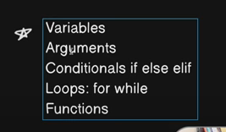

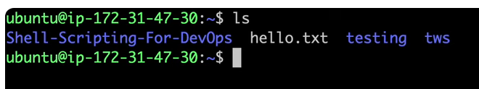

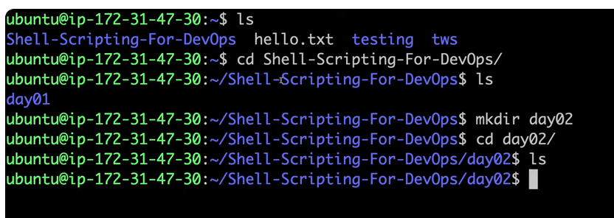

What is variable?

Create a file in day02 folder

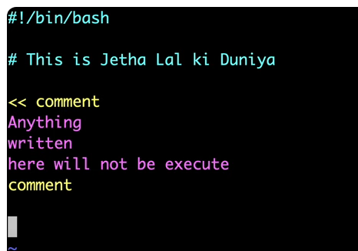

Multiline comment is above

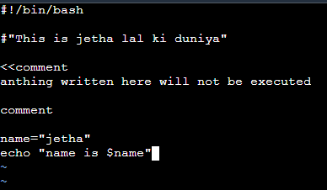

Now check permissions

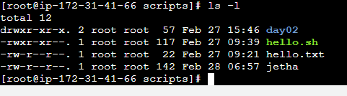

Give permissions

Now its showing green means its shell scrio file

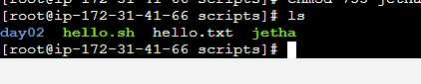

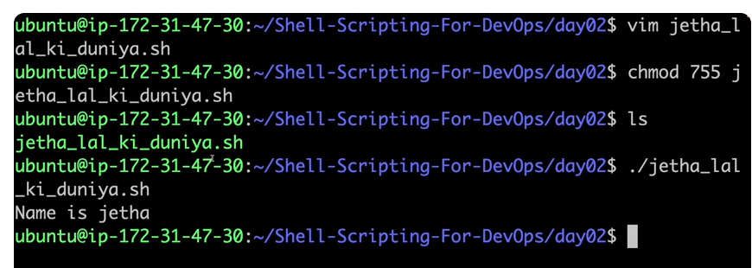

Now change the jetha to babita ji

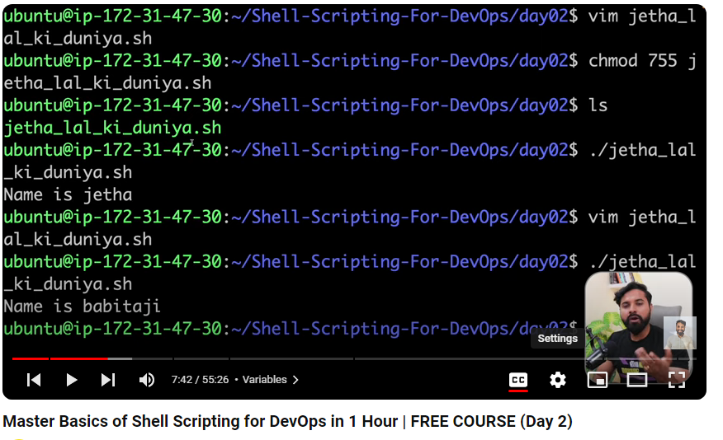

What is varibales

Now make it executable by ./

Value is varibale jetha to babitaji

Run a command as veriable

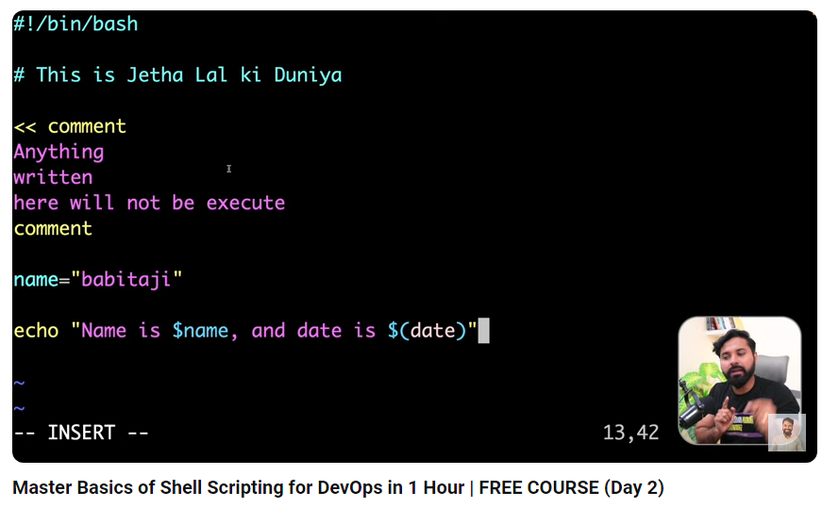

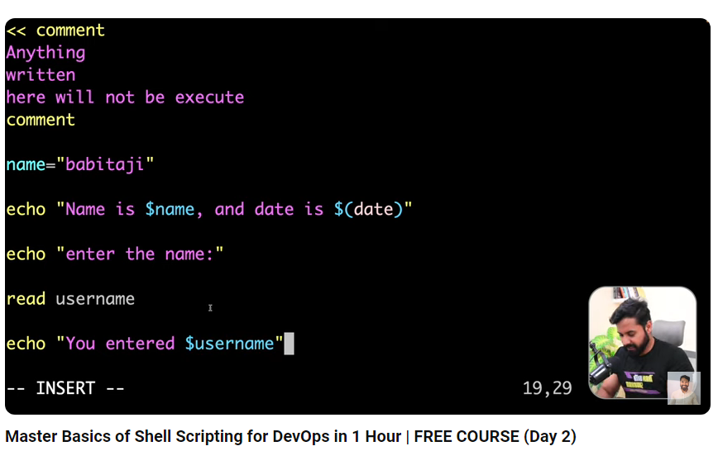

Its used is creating auser

Create file from vi editir

U can run a script using bash file name or ./file name

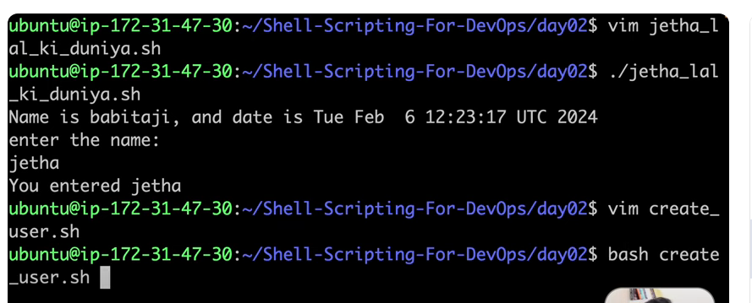

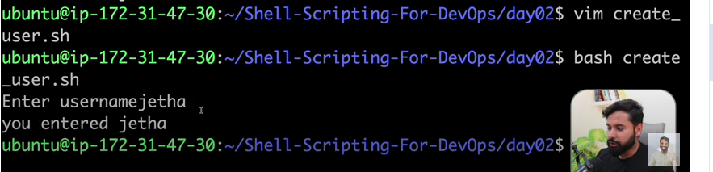

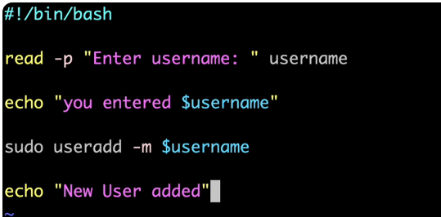

Save the file

Permissions given



U can see the users in this path

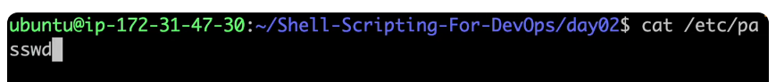

Jetha user is added

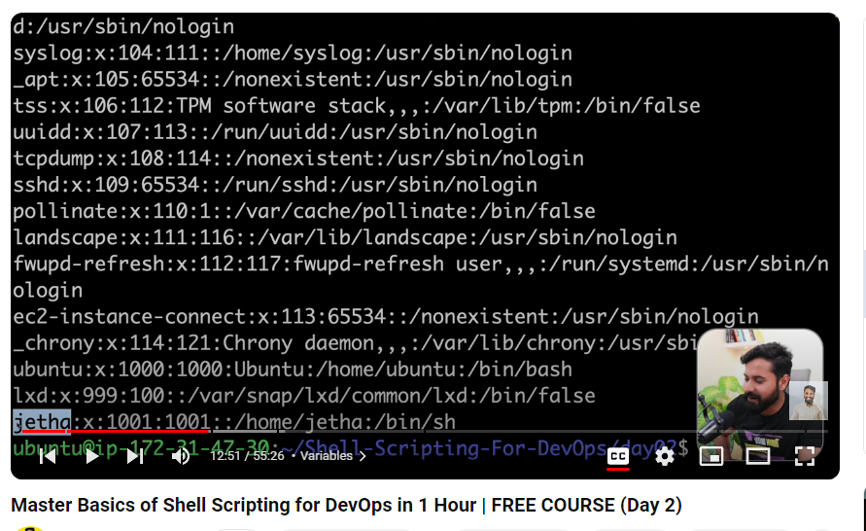

What is arguments?

Open the file

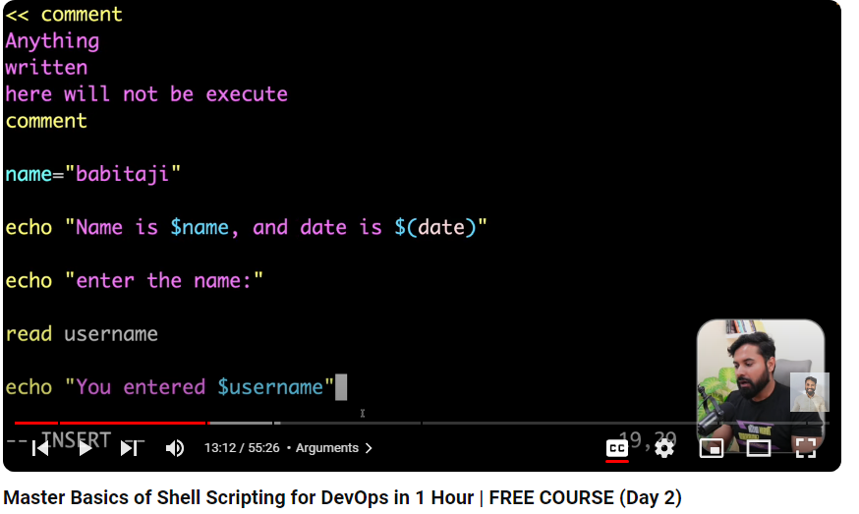

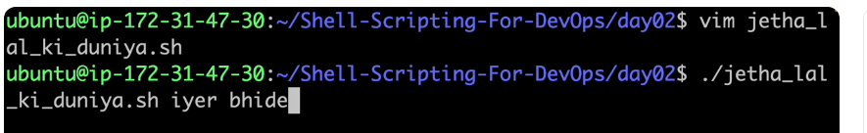

These are 1 and 2 arguments ( iyer and bhide )

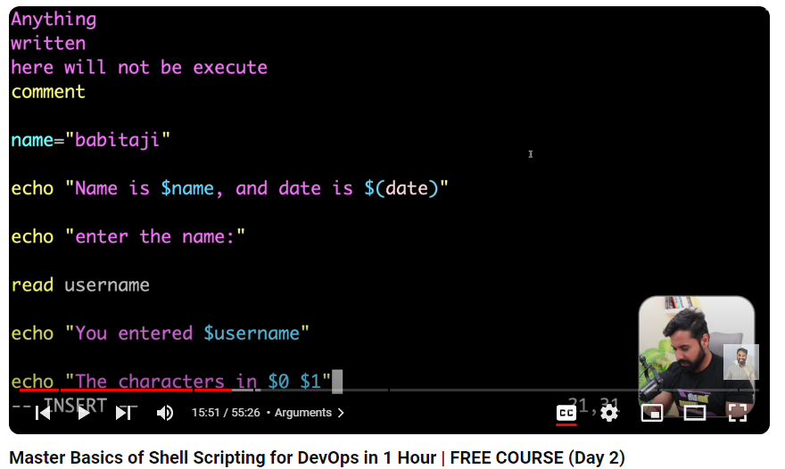

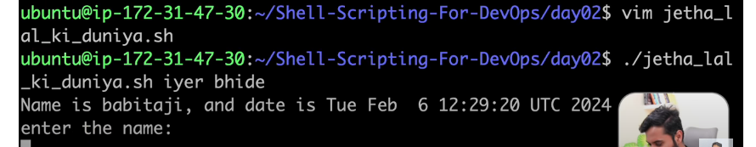

Run the now



